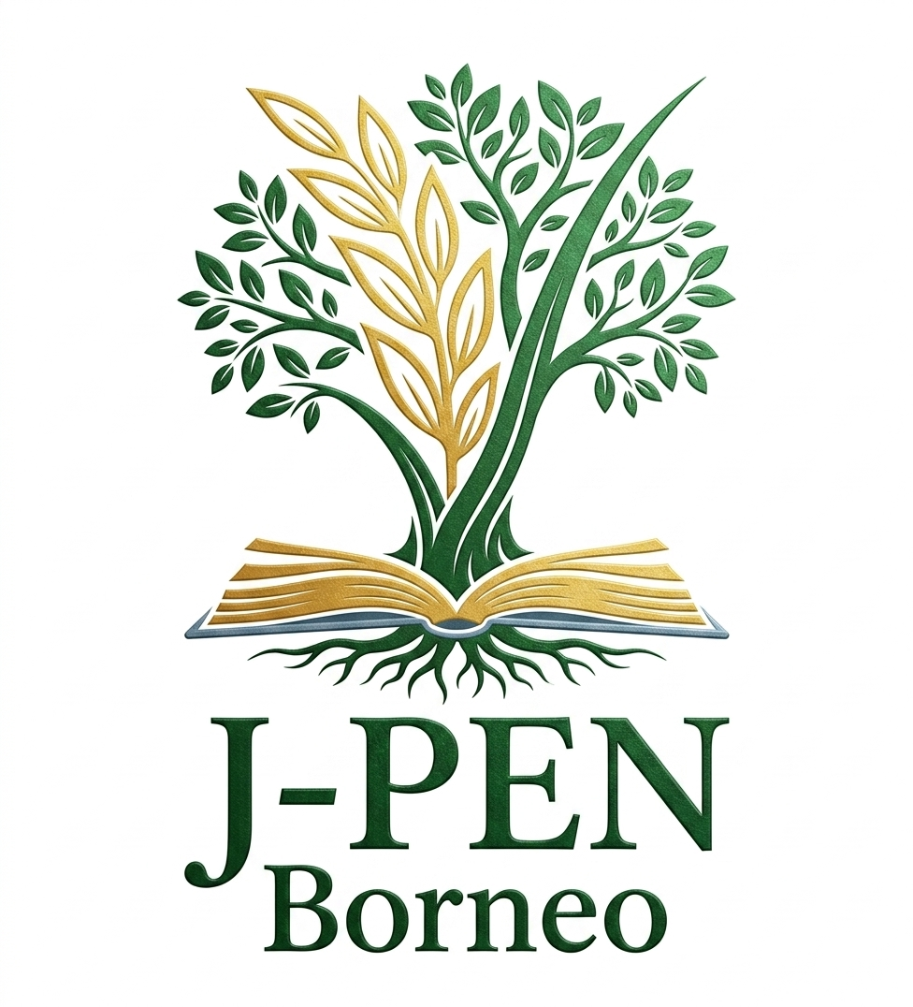 | E-ISSN 2599-2872; P-ISSN 2549-8150  J-PEN Borneo: Jurnal Ilmu Pertanian  journal homepage: https://jurnal.ubt.ac.id/index.php/jpen | 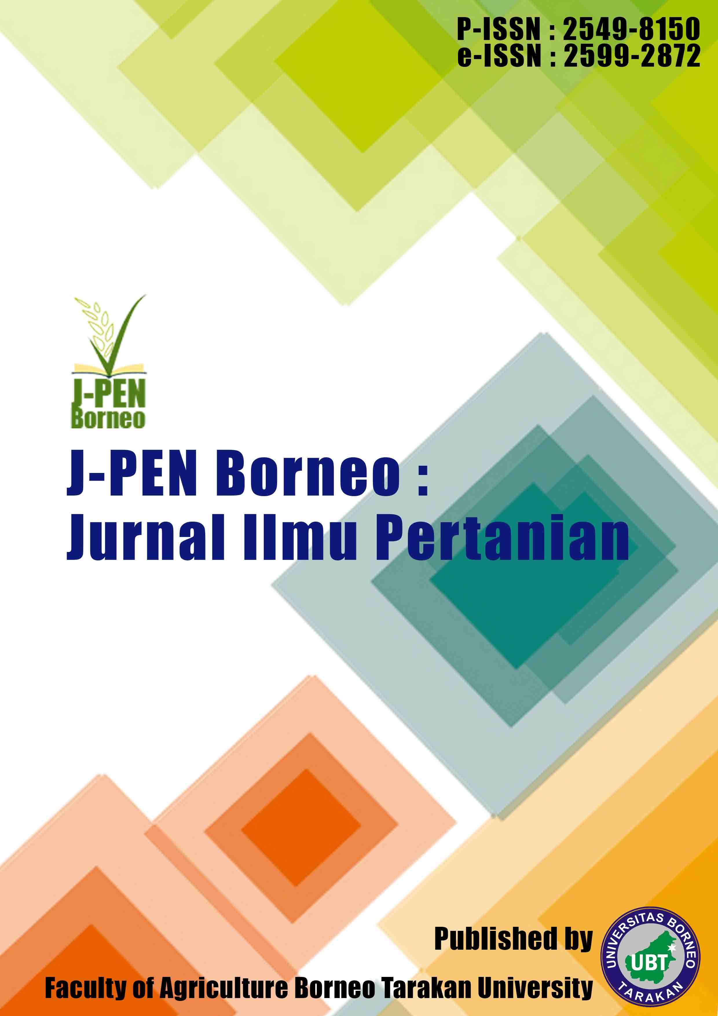

Research Paper 8(2) (2025) 8-14

Feasibility and Development Strategy of Soybean Agroindustry in South Sorong Regency
Yusni Kristiani¹*, Sri Anggasari Makatita¹
¹Agribusiness Study Program, Universitas Werisar, South Sorong, Indonesia
* Corresponding author. E-mail address: yusnihasian1995@gmail.com

Submitted/Received: 20 April 2025 ; Accepted: 30 June 2025

A R T I C L E I N F O  Keywords:  business feasibility  development strategy  small-scale agroindustry  soybean  SWOT | A B S T R A C T  Migrant communities have contributed to efforts to address food-related problems in South Sorong Regency by developing small-scale soybean agroindustries that produce plant-protein products, particularly tempeh and tofu. In addition to meeting plant-protein needs, these businesses provide household income. However, although soybean processing enterprises have operated for many years, their feasibility and development direction have not been clearly documented. This study aimed to assess the feasibility of small-scale soybean agroindustry and to formulate its development strategy. A census method was used to collect data from all soybean agroindustry actors in the study area. Business feasibility was assessed from financial, market, and management aspects, while development strategies were formulated using SWOT analysis. The results show that, from the financial aspect, most soybean agroindustry enterprises in South Sorong Regency had an R/C ratio above 1, indicating that the businesses were feasible. From the market aspect, soybean agroindustry was also feasible because the market served both migrant communities and Indigenous Papuan consumers. From the management aspect, the businesses were considered feasible because they had continued to operate for several years. Therefore, soybean agroindustry development requires the formulation of clear SO, WO, ST, and WT strategies.

INTRODUCTION
Food is a basic human need that supports individual survival and must be fulfilled in terms of both quality and quantity. Food has an essential role in human life because it cannot be replaced by any other need. For this reason, the Indonesian government guarantees food availability for all citizens as a human right, as mandated in Law No. 18 of 2012 on Food [1].
Although the law mandates food availability for all Indonesians, food-related problems continue to occur, particularly among poor rural communities. One area facing such challenges is South Sorong Regency, Southwest Papua Province. According to Tribun Sorong, the Head of the South Sorong Food Security Office stated that food problems in South Sorong include stunting, extreme poverty, and inflation [2].
One effort made by migrant communities to help address food problems is the establishment of small-scale soybean agroindustries that produce plant-protein products such as tempeh, tofu, and soybean milk for both migrant and local communities in South Sorong Regency. These enterprises not only help meet the demand for plant protein but also increase household income.
Although soybean processing businesses have operated for years, most remain small in scale and have not yet adopted new soybean-processing technologies. Business innovation is also still limited, and the feasibility of these enterprises has not been fully identified. Based on these conditions, this study examined the feasibility and development strategy of soybean agroindustry in South Sorong Regency. The research questions were: (1) is small-scale soybean agroindustry in South Sorong Regency feasible to operate? and (2) what development strategies are appropriate for small-scale soybean agroindustry in South Sorong Regency? Accordingly, this study aimed to assess business feasibility and formulate development strategies for small-scale soybean agroindustry in South Sorong Regency.
MATERIALS AND METHODS
The study was conducted in South Sorong Regency, Southwest Papua Province. The research location was selected based on a census of all soybean agroindustry enterprises operating in the regency. This study used a quantitative approach with a census method that included all entrepreneurs who owned soybean agroindustry businesses in the study area.
The research was conducted for one month, from 17 March 2025 to 17 April 2025. The data consisted of primary data and supporting secondary data. The units of observation were the types of soybean agroindustry enterprises and the business owners who operated them. Data analysis was conducted according to the research objectives.
Business feasibility indicators followed Arum et al. [3], who assessed feasibility from financial, market, and management aspects. The financial aspect was analyzed quantitatively, whereas the market and management aspects were analyzed descriptively. Financial feasibility was assessed using the R/C ratio (revenue-cost ratio). According to Soekartawi [4], the R/C ratio is the comparison between revenue and production cost. The formula is as follows:
R/C Ratio = TR / TC
where R/C Ratio is the revenue-cost ratio, TR is total revenue (IDR), and TC is total production cost (IDR). The feasibility criteria were: RCR > 1 indicates that the soybean agroindustry is feasible to develop; RCR = 1 indicates a break-even condition; and RCR < 1 indicates that the soybean agroindustry is not feasible to develop.
SWOT analysis was used to formulate the development strategy for soybean agroindustry in South Sorong Regency. SWOT analysis is a strategic analysis tool used in business and organizational management to identify internal and external factors that influence goal achievement. Rangkuti [5] stated that SWOT analysis is conducted systematically to support comprehensive and directed planning so that organizations can achieve both short-term and long-term objectives.
RESULTS AND DISCUSSION
History of soybean agroindustry in South Sorong Regency
South Sorong Regency is one of the regencies in Southwest Papua Province, with a population consisting of Indigenous Papuans and non-Indigenous Papuans (Amber). One ethnic group that has settled in South Sorong Regency is the Javanese community. The presence of the Javanese community has played an important role in the development of the agricultural sector in South Sorong, as reflected in the large number of Javanese residents working in agriculture.
One contribution of the Javanese community to agriculture in South Sorong Regency is the establishment of soybean agroindustry enterprises that produce tempeh and tofu. Soybean agroindustry developed alongside the arrival of the Javanese community in South Sorong. As a result, tempeh and tofu, which were initially known as typical Javanese foods, have become recognized and consumed by communities in eastern Indonesia, where soybean is not a local staple food. Soybean agroindustry in South Sorong Regency has operated for approximately 20 years, generally at a small scale and using simple equipment.
Characteristics of business owners
The respondents in this study were soybean business owners in South Sorong Regency. Their characteristics included age, education level, business duration, and type of soybean enterprise, as presented in Table 1.

Table 1. Characteristics of soybean agroindustry business owners in South Sorong Regency
No. | Business owner | Age (years) | Education level | Business duration (years) | Business type
1 | 1 | 55 | Elementary school | 13 | Tempeh and tofu
2 | 2 | 53 | Junior high school | 14 | Tempeh and tofu
3 | 3 | 39 | Elementary school | 3 | Tempeh and tofu
4 | 4 | 55 | Elementary school | 2 | Tofu
5 | 5 | 51 | Elementary school | 20 | Tofu
Source: Primary data (2025).

Table 1 shows that soybean agroindustry actors were generally older than 39 years and had relatively low formal education. This condition indicates that agricultural processing activities are still less attractive to younger people, who often perceive agricultural work as less prestigious and less promising for the future. Similarly, people with higher education tend to prefer office-based employment rather than farming or agricultural processing. Zapico et al. [6] noted that the perception of agriculture as a less prestigious livelihood influences the mindset of rural youth, encouraging them to migrate to urban areas in search of employment and education.
Technical agricultural work is often used as a marker of social status within the community. Office work is generally viewed as having higher social standing than farming. In addition, farming is considered accessible to many groups because its work processes are relatively easy to learn. Therefore, older people and those with low education levels can continue to work in agricultural activities.
Production cost and income of soybean agroindustry
The largest production cost was recorded by the soybean agroindustry owned by K, amounting to IDR 1,011,710,000, followed by Mo with IDR 265,558,333, J with IDR 209,483,810, Ma with IDR 90,273,333, and S with IDR 56,976,667. Income varied among enterprises and was influenced by the amount of production cost incurred. The larger the production cost, the higher the income that could be received by business owners. Sasongko et al. [7] also found that production costs and operational costs had a positive and significant effect on increasing business profit. Aidore et al. [8] stated that fixed costs are costs whose value is not affected by production level or output quantity. In this study, production costs consisted of fixed and variable costs.
The results indicate that income from four soybean agroindustry enterprises in South Sorong Regency was correlated with the production costs incurred, while one enterprise differed from the others, namely the enterprise owned by Mulyano. The enterprise owned by K obtained annual income of IDR 281,890,000, followed by J with IDR 114,516,190, Mo with IDR 103,558,333, S with IDR 94,223,333, and Ma with IDR 13,406,667. Mulyano's enterprise had the third-highest production cost among the five enterprises and also generated the third-highest income.
Feasibility of soybean agroindustry
Financial aspect
The R/C ratio obtained by each soybean agroindustry enterprise in South Sorong Regency is presented in Table 2.

Table 2. R/C ratio of soybean agroindustry enterprises in South Sorong Regency
No. | Business owner | R/C ratio
1 | K | 1.3
2 | S | 2.6
3 | Mo | 0.6
4 | Ma | 1.1
5 | J | 1.5
Source: Primary data (2025).

From the financial feasibility aspect, business owners K, S, Ma, and J had R/C ratios greater than 1 and therefore met the feasibility criterion. Owner K obtained an R/C ratio of 1.3, meaning that each IDR 1 spent generated revenue equivalent to IDR 1.3. Owner S obtained the highest R/C ratio, 2.6, indicating that each IDR 1 spent generated revenue equivalent to IDR 2.6. Owner Mo obtained a low R/C ratio of 0.6, indicating that this enterprise was not financially feasible. Owner Ma obtained an R/C ratio of 1.1, while J obtained 1.5.
Market aspect
The study found that tempeh and tofu production by all business owners in South Sorong Regency contributed to meeting the plant-protein needs of migrant and local communities. Annual demand was estimated at 487,296 kg for tempeh and 607,680 kg for tofu; therefore, producers attempted to meet this demand. Although tempeh and tofu are not local Papuan foods, communities in South Sorong have gradually begun consuming them because they are relatively affordable and accepted by various social groups. This condition is consistent with Indonesia's position as a major tempeh and tofu producer [10]. Tempeh and tofu are easy to find in traditional markets in South Sorong, indicating market acceptance and strong development opportunities.
Management aspect
Management is a determining factor in the success of tempeh and tofu agroindustry. Organized management supports the achievement of business objectives, particularly income growth. Kasmir and Jakfar [9] stated that business planning is easier to implement when owners carry out management functions properly. Based on the findings, owner K employed four workers from outside the family and paid each worker IDR 1,000,000 per month to process soybean into tempeh and tofu. Meanwhile, owners Sujono, Mulyano, Marsina, and Jumaiyah relied on family labor, generally involving two family members, namely husband and wife.
Internal and external factors of soybean agroindustry
This study used SWOT analysis as the main analytical tool. This approach is based on efforts to optimize strengths and opportunities while reducing weaknesses and anticipating threats that can influence the achievement of business objectives.
Strengths
Strengths are important internal aspects that business owners need to understand in order to develop their enterprises. The strength position of soybean agroindustry in South Sorong Regency is shown in Table 3.

Table 3. Internal factor evaluation matrix for strengths (K, S, and Mo)
No. | Factor | K |  |  | S |  |  | Mo
 |  | R | W | W x R | R | W | W x R | R | W | W x R
1 | Tempeh/tofu production technology is easy | 4 | 0.2 | 0.8 | 3 | 0.2 | 0.6 | 4 | 0.2 | 0.8
2 | Hygiene and quality are maintained | 4 | 0.2 | 0.8 | 2 | 0.1 | 0.3 | 4 | 0.2 | 0.8
3 | Broad market share | 4 | 0.2 | 0.8 | 4 | 0.3 | 1.0 | 4 | 0.2 | 0.8
4 | Labor is always available | 4 | 0.2 | 0.8 | 3 | 0.2 | 0.6 | 3 | 0.2 | 0.5
5 | Cultural knowledge of making tempeh/tofu | 4 | 0.2 | 0.8 | 4 | 0.3 | 1.0 | 4 | 0.2 | 0.8
Total |  | 20 | 1.0 | 4.0 | 16 | 1.0 | 3.4 | 19 | 1.0 | 3.8
Table 3. Internal factor evaluation matrix for strengths (Ma and J)
No. | Factor | Ma |  |  | J
 |  | R | W | W x R | R | W | W x R
1 | Tempeh/tofu production technology is easy | 3 | 0.2 | 0.6 | 3 | 0.2 | 0.6
2 | Hygiene and quality are maintained | 3 | 0.2 | 0.6 | 3 | 0.1 | 0.4
3 | Broad market share | 3 | 0.2 | 0.6 | 3 | 0.3 | 0.8
4 | Labor is always available | 3 | 0.2 | 0.6 | 3 | 0.2 | 0.6
5 | Cultural knowledge of making tempeh/tofu | 4 | 0.3 | 1.0 | 4 | 0.3 | 1.0
Total |  | 16 | 1.0 | 3.3 | 16 | 1.0 | 3.3
Source: Primary data (2025).
Notes: R = rating; W = weight; W x R = weighted score. Weighting scale: 1 = slightly important, 2 = moderately important, 3 = important, 4 = very important. Strength rating scale: 1 = slightly strong, 2 = moderately strong, 3 = strong, 4 = very strong.

Based on Table 3, the internal strength factor for the soybean agroindustry owned by K received a rating of 4, indicating a very strong position. Owner S received ratings ranging from moderately strong to very strong. Owners Mo, Ma, and J also received strong and very strong ratings. The high strength ratings indicate that soybean agroindustry enterprises in South Sorong Regency are in a strong position to survive. This finding is consistent with Haida et al. [11], who explained that a rating of 4 represents a very strong condition.
Weaknesses
Every business has internal weaknesses. If these weaknesses are not addressed, they can affect business development and may even hinder the continuity of soybean agroindustry. The weaknesses of soybean agroindustry in South Sorong Regency are presented in Table 4.

Table 4. Internal factor evaluation matrix for weaknesses (K, S, and Mo)
No. | Factor | K |  |  | S |  |  | Mo
 |  | R | W | W x R | R | W | W x R | R | W | W x R
1 | Tempeh/tofu has a short shelf life | 1 | 0.2 | 0.2 | 1 | 0.1 | 0.1 | 1 | 0.2 | 0.2
2 | Lack of promotion | 1 | 0.2 | 0.2 | 1 | 0.1 | 0.1 | 1 | 0.2 | 0.2
3 | Limited capital | 1 | 0.2 | 0.2 | 2 | 0.3 | 0.6 | 2 | 0.3 | 0.7
4 | Limited number of processing machines | 1 | 0.2 | 0.2 | 2 | 0.3 | 0.6 | 1 | 0.2 | 0.2
5 | Difficulty obtaining raw materials | 1 | 0.2 | 0.2 | 1 | 0.1 | 0.1 | 1 | 0.2 | 0.2
Total |  | 5 | 1.0 | 1.0 | 7 | 1.0 | 1.6 | 6 | 1.0 | 1.3
Table 4. Internal factor evaluation matrix for weaknesses (Ma and J)
No. | Factor | Ma |  |  | J
 |  | R | W | W x R | R | W | W x R
1 | Tempeh/tofu has a short shelf life | 1 | 0.1 | 0.1 | 1 | 0.1 | 0.1
2 | Lack of promotion | 1 | 0.1 | 0.1 | 1 | 0.1 | 0.1
3 | Limited capital | 2 | 0.3 | 0.6 | 2 | 0.3 | 0.6
4 | Limited number of processing machines | 2 | 0.3 | 0.6 | 2 | 0.3 | 0.6
5 | Difficulty obtaining raw materials | 1 | 0.1 | 0.1 | 1 | 0.1 | 0.1
Total |  | 7 | 1.0 | 1.6 | 7 | 1.0 | 1.6
Source: Primary data (2025).
Notes: R = rating; W = weight; W x R = weighted score. Weakness rating scale: 1 = slightly poor, 2 = poor, 3 = worrying, 4 = dangerous.

Table 4 shows that soybean agroindustry enterprises in South Sorong Regency generally obtained weakness ratings of 1 and 2, indicating slightly poor to poor conditions. None of the weakness indicators reached the worrying (3) or dangerous (4) categories. This is a positive sign for business owners because their enterprises were not in a condition close to failure.
Opportunities
External opportunities can support business development if soybean agroindustry owners are able to identify and use them optimally. The opportunities available to soybean agroindustry in South Sorong Regency are presented in Table 5.

Table 5. External factor evaluation matrix for opportunities (K, S, and Mo)
No. | Factor | K |  |  | S |  |  | Mo
 |  | R | W | W x R | R | W | W x R | R | W | W x R
1 | Good market share | 4 | 0.2 | 0.9 | 4 | 0.3 | 1.1 | 4 | 0.3 | 1.1
2 | Promising profit | 4 | 0.2 | 0.9 | 4 | 0.3 | 1.1 | 4 | 0.3 | 1.1
3 | Potential to produce derivative products | 4 | 0.2 | 0.9 | 1 | 0.1 | 0.1 | 1 | 0.1 | 0.1
4 | High product demand | 4 | 0.2 | 0.9 | 4 | 0.3 | 1.1 | 4 | 0.3 | 1.1
5 | Government support | 1 | 0.1 | 0.1 | 1 | 0.1 | 0.1 | 1 | 0.1 | 0.1
Total |  | 17 | 1.0 | 3.8 | 14 | 1.0 | 3.5 | 14 | 1.0 | 3.6
Table 5. External factor evaluation matrix for opportunities (Ma and J)
No. | Factor | Ma |  |  | J
 |  | R | W | W x R | R | W | W x R
1 | Good market share | 4 | 0.3 | 1.1 | 4 | 0.3 | 1.1
2 | Promising profit | 4 | 0.3 | 1.1 | 4 | 0.3 | 1.1
3 | Potential to produce derivative products | 1 | 0.1 | 0.1 | 1 | 0.1 | 0.1
4 | High product demand | 4 | 0.3 | 1.1 | 4 | 0.3 | 1.1
5 | Government support | 1 | 0.1 | 0.1 | 1 | 0.1 | 0.1
Total |  | 14 | 1.0 | 3.6 | 14 | 1.0 | 3.6
Source: Primary data (2025).
Notes: R = rating; W = weight; W x R = weighted score. Opportunity rating scale: 1 = slightly strong, 2 = moderately strong, 3 = strong, 4 = very strong.

Table 5 shows that all business owners obtained a rating of 1 for the government support indicator. Based on interviews with business owners, the study found that there had been no support from the central, provincial, or local government in the form of capital assistance, equipment, or other support for enterprises that help meet the plant-protein needs of communities in South Sorong Regency. As a result, the score for government support remained low. Lermating et al. [12] stated that working capital is a very important factor in business because it provides the resources required for daily operations and business activities. Paiki et al. [13] also noted that advanced food technology can process food into products that are both palatable and highly nutritious. Daily demand for tempeh and tofu in South Sorong Regency is high because these products are consumed by households, purchased regularly by fried-snack sellers, and bought by consumers from neighboring regencies.
Threats
Threats are external factors that can cause losses or even business failure if they are not managed properly. The threat factors affecting soybean agroindustry in South Sorong Regency are shown in Table 6.

Table 6. External factor evaluation matrix for threats (K, S, and Mo)
No. | Factor | K |  |  | S |  |  | Mo
 |  | R | W | W x R | R | W | W x R | R | W | W x R
1 | Simple processing technology | 1 | 0.2 | 0.2 | 2 | 0.3 | 0.5 | 1 | 0.1 | 0.1
2 | Price fluctuation | 1 | 0.2 | 0.2 | 1 | 0.1 | 0.1 | 1 | 0.1 | 0.1
3 | Expensive soybean raw materials | 2 | 0.3 | 0.7 | 2 | 0.3 | 0.5 | 2 | 0.3 | 0.6
4 | Many competitors | 1 | 0.2 | 0.2 | 1 | 0.1 | 0.1 | 1 | 0.1 | 0.1
5 | Limited firewood | 1 | 0.2 | 0.2 | 2 | 0.3 | 0.5 | 2 | 0.3 | 0.6
Total |  | 6 | 1.0 | 1.3 | 8 | 1.0 | 1.8 | 7 | 1.0 | 1.6
Table 6. External factor evaluation matrix for threats (Ma and J)
No. | Factor | Ma |  |  | J
 |  | R | W | W x R | R | W | W x R
1 | Simple processing technology | 1 | 0.1 | 0.1 | 1 | 0.1 | 0.1
2 | Price fluctuation | 1 | 0.1 | 0.1 | 1 | 0.1 | 0.1
3 | Expensive soybean raw materials | 2 | 0.3 | 0.6 | 2 | 0.3 | 0.6
4 | Many competitors | 1 | 0.1 | 0.1 | 1 | 0.1 | 0.1
5 | Limited firewood | 2 | 0.3 | 0.6 | 2 | 0.3 | 0.6
Total |  | 7 | 1.0 | 1.6 | 7 | 1.0 | 1.6
Source: Primary data (2025).
Notes: R = rating; W = weight; W x R = weighted score. Threat rating scale: 1 = slightly poor, 2 = poor, 3 = worrying, 4 = dangerous.

The threat factors in Table 6 show that all soybean business owners obtained a poor rating (2) for the indicator of expensive soybean raw materials. Field findings showed that business owners purchased soybean raw materials from outside South Sorong Regency, specifically from Sorong Regency, at prices ranging from IDR 720,000 to IDR 825,000 per 50-kg sack. In addition, business owners incurred extra transportation costs to move soybeans from Sorong Regency to South Sorong Regency, which involves a considerable distance.
SWOT matrix
The SWOT matrix was used to determine development strategies for soybean agroindustry in South Sorong Regency. Makatita et al. [14] stated that SWOT analysis is a basic analytical method that is useful for examining topics and problems from four perspectives: strengths, weaknesses, opportunities, and threats.

Table 7. SWOT matrix for soybean agroindustry development in South Sorong Regency
External factors / Internal factors | Strengths (S)  S1. Easy tempeh/tofu production technology  S2. Hygiene and quality are maintained  S3. Broad market share  S4. Labor is always available  S5. Cultural knowledge of making tempeh/tofu | Weaknesses (W)  W1. Short shelf life of tempeh/tofu  W2. Lack of promotion  W3. Limited capital  W4. Limited processing machines  W5. Difficulty obtaining raw materials
Opportunities (O)  O1. Good market share  O2. Promising profit  O3. Potential derivative products  O4. High product demand  O5. Government support | SO strategies  1. Expand the business scale.  2. Expand marketing to neighboring regencies.  3. Process tofu by-products into superior derivative products.  4. Produce soybean milk. | WO strategies  1. Promote products through social media.  2. Discuss support opportunities with government institutions.  3. Add tempeh and tofu production machines.
Threats (T)  T1. Simple processing technology  T2. Price fluctuation  T3. Expensive soybean raw materials  T4. Many competitors  T5. Limited firewood | ST strategies  1. Improve tempeh and tofu quality to reduce spoilage.  2. Participate in soybean-processing training.  3. Increase the number of workers. | WT strategies  1. Improve business management.  2. Maintain sanitation and cleanliness during tempeh and tofu processing.
Source: Primary data (2025).

CONCLUSION
From the financial aspect, four soybean agroindustry business owners in South Sorong Regency had R/C ratios greater than 1: K with 1.3, S with 2.6, Ma with 1.1, and J with 1.5. These values indicate that the soybean agroindustry enterprises were feasible. Owner Mo obtained an R/C ratio of 0.6, indicating that the enterprise was not feasible to develop from the financial aspect. From the market aspect, soybean agroindustry was feasible because its market served migrant communities and Indigenous Papuans and even reached Maybrat Regency. Annual demand in South Sorong Regency was estimated at 487,296 kg for tempeh and 607,680 kg for tofu. From the management aspect, soybean agroindustry was also feasible because the enterprises continued to operate for many years despite relying mainly on family labor.
The SWOT matrix describes the external and internal conditions of soybean agroindustry enterprises in South Sorong Regency. Therefore, in order for soybean agroindustry to develop, business owners need to formulate and implement SO, WO, ST, and WT strategies.
REFERENCES
[1] Undang-Undang Republik Indonesia Nomor 18 Tahun 2012 tentang Pangan. https://badanpangan.go.id/storage/app/media/informasi%20publik/Peraturan/UU/UU_Nomor_18_Tahun_2012.pdf.
[2] Pulo, P. (2023). Atasi Kemiskinan Ekstrem, Dinas Ketahanan Pangan Sorong Selatan Ajak Warga Menanam. Tribun Sorong. https://sorong.tribunnews.com/2023/04/12/atasi-kemiskinan-ekstrem-dinas-ketahanan-pangan-sorong-selatan-ajak-warga-menanam.
[3] Arum, W. P., Widjaya, S., & Marliana, L. (2017). Kelayakan usaha dan nilai tambah agroindustri tempe. Jurnal JIIA, 5(2), 124-133.
[4] Soekartawi. (2002). Prinsip Dasar Ekonomi Pertanian: Teori dan Aplikasi. PT Raja Grafindo.
[5] Rangkuti, F. (2009). Strategi Promosi yang Kreatif dan Analisis Kasus Integrated Marketing Communication. PT Gramedia Pustaka Utama.
[6] Zapico, F., Hernandez, J., Borromeo, T., Mcnally, K., Dizon, J., Baños, L., & Fernando, E. (2019). Traditional agro-ecosystems in the Southern Philippines: Vulnerabilities, threats and interventions. 10(4), 289-300.
[7] Sasongko, T., Irian, N. I., & Ernawati, E. (2021). Pengaruh biaya produksi dan biaya operasional terhadap laba perusahaan. Jurnal Ilmu Manajemen dan Akuntansi, 9(2), 213-218.

[8] Aidore, H. J. Y., Dara Anna, Lermating, K. F., & Makatita, S. A. (2023). Pemasaran kepiting bakau secara tradisional oleh masyarakat Kampung Sayolo Distrik Teminabuan Kabupaten Sorong Selatan. Jurnal Administrasi Terapan, 2(2), 329-339.
[9] Kasmir, & Jakfar. (2012). Studi Kelayakan Bisnis (Edisi Revisi). Kencana.
[10] Komalasari, W. B. (2008). Prediksi penawaran dan permintaan kedelai dengan analisis deret waktu. Jurnal Informatika Pertanian, 7(2), 1195-1209.
[11] Haida, N., Girsang, W., Timisela, N. R., & Makatita, S. A. (2022). Analysis of the Bumdes institutions existence on community income levels (Case study in Waeapo District, Buru Regency). Jurnal Social of Economics Agriculture, 11(2), 58-69.
[12] Lermating, K. F., Makatita, S. A., Aidore, H. J. Y., & Paiki, F. D. (2023). Analisis pengaruh modal kerja, produktivitas kerja dan harga komoditi pinang terhadap pendapatan pengecer pinang di Distrik Teminabuan Kabupaten Sorong Selatan Provinsi Papua Barat Daya. Jurnal Administrasi Terapan, 2(1), 131-142.
[13] Paiki, F. D., Makatita, S. A., Lermating, K. F., & Aidore, H. J. Y. (2022). Potensi jenis-jenis sagu di Distrik Kais Kabupaten Sorong Selatan. Jurnal Administrasi Terapan, 1(1), 181-193.
[14] Makatita, S. A., Girsang, W., & Sahusilawan, A. M. (2021). Strategi pengembangan usaha peternakan ayam broiler terintegrasi dengan dusung (Studi kasus di Negeri Leahari, Kecamatan Leitimur Selatan Kota Ambon). Jurnal Agribisnis Kepulauan, 9(3), 222-235.

