 | E-ISSN 2599-2872; P-ISSN 2549-8150  J-PEN Borneo: Jurnal Ilmu Pertanian  journal homepage: https://jurnal.ubt.ac.id/index.php/jpen | 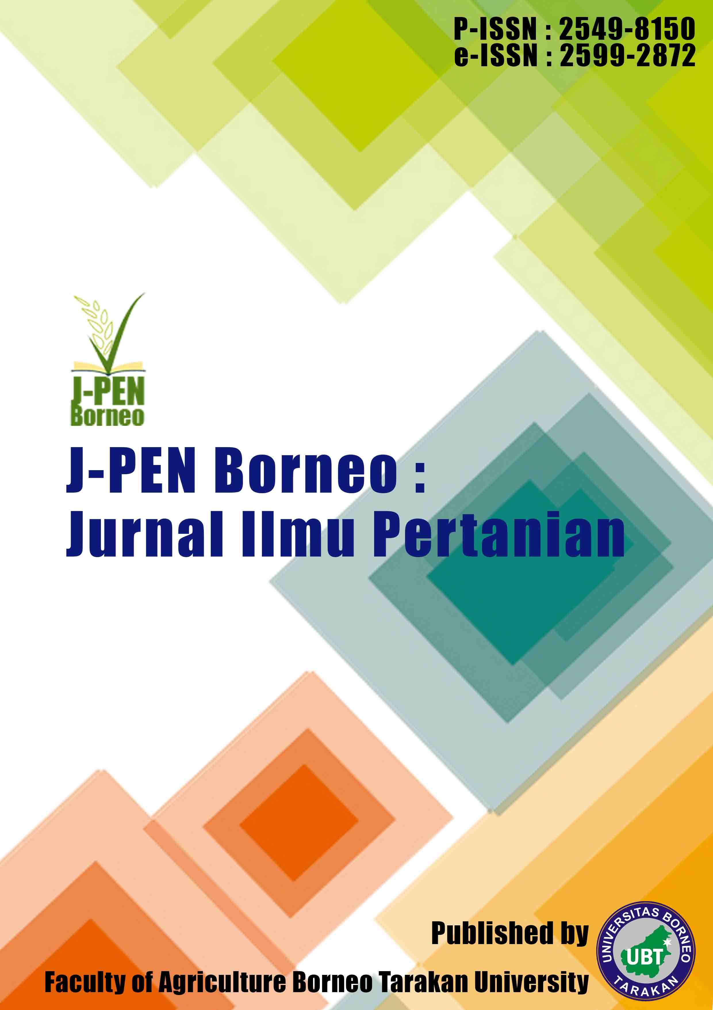

Research Paper 8(2) (2025) 15-19
Effectiveness of aloe vera gel as a natural plant growth regulator in white jasmine cuttings
Amelia Rahmadani¹, Nurul Chairiyah^{1*}, Siti Zahara¹, Abdul Rahim¹, Amarullah¹
¹ Department of Agrotechnology, Faculty of Agriculture, Universitas Borneo Tarakan, Jl. Amal Lama No. 01, Tarakan 77115, North Kalimantan, Indonesia
* Corresponding author. E-mail address: nchairiyah@borneo.ac.id

Submitted/Received: 23 April 2025; Accepted: -;13 July 2025

A R T I C L E I N F O  Keywords:  Aloe vera  growth regulator  rooting  vegetative propagation  white jasmine | A B S T R A C T  Propagation of white jasmine (Jasminum sambac L.) through stem cuttings is often constrained by low rooting success and limited shoot development during the early stages of growth. The use of natural plant growth regulators (PGRs) derived from aloe vera (Aloe vera L.) has emerged as an environmentally friendly alternative to improve the success of vegetative propagation. This study aimed to evaluate the effects of different doses of aloe vera gel on the growth of white jasmine cuttings and to determine the optimum dose for promoting vegetative development. The experiment was arranged in a Randomized Complete Block Design with a single factor consisting of four aloe vera gel doses (100, 200, 300, and 400 g), each replicated four times. Observed variables included plant height, number of leaves, number of roots, and root length. Data were analyzed using analysis of variance (ANOVA), followed by Duncan's Multiple Range Test (DMRT) at the 5% significance level. The results revealed that aloe vera gel significantly affected all growth parameters. The application of 300 g aloe vera gel produced the best growth performance, resulting in a plant height of 15.10 cm, 9.75 roots, a root length of 4.00 cm, and 9.50 leaves at 8 weeks after planting. These findings suggest that aloe vera gel can serve as an effective natural source of phytohormones to enhance rooting and vegetative growth of white jasmine cuttings.

INTRODUCTION
White jasmine (Jasminum sambac L.) is an ornamental plant with high economic value due to its extensive use in the perfume, aromatic tea, cosmetic, and essential oil industries [1]. The increasing demand for jasmine flowers has led to a growing need for high-quality planting materials that can be produced efficiently and sustainably. Therefore, the development of effective propagation techniques is essential to support the large-scale production of white jasmine [2].
Vegetative propagation through stem cuttings is widely employed in jasmine cultivation because it enables the production of genetically uniform plants and facilitates rapid multiplication of desirable genotypes [2]. This method is relatively simple, cost-effective, and capable of producing planting materials more rapidly than seed propagation. However, the success of stem cuttings is often constrained by limited rooting ability during the early stages of growth, which is influenced by factors such as cutting type, growing medium, and the availability of growth-promoting substances [3]. Poor root development limits water and nutrient uptake, ultimately reducing plant establishment and vegetative growth [4].
The application of plant growth regulators (PGRs) is a common approach to enhance root initiation and improve the success of vegetative propagation [5]. Although synthetic PGRs have been proven effective in stimulating root formation, their relatively high cost and increasing concerns regarding environmentally sustainable cultivation practices have encouraged the exploration of natural alternatives [6]. Among the potential natural sources of PGRs, aloe vera (Aloe vera L.) has attracted considerable attention due to its rooting-promoting properties and its abundance of bioactive compounds that support plant growth and development [7].
Aloe vera gel contains various bioactive compounds, including auxins, gibberellins, cytokinins, amino acids, vitamins, and minerals that contribute to plant growth and development [5,7]. These compounds can stimulate adventitious root formation, enhance cell division, and promote shoot and leaf development. Previous studies have demonstrated the effectiveness of aloe vera gel as a natural growth-promoting substance in horticultural crops. Nasution et al. [8] reported improved root growth in rose cuttings treated with aloe vera gel, while El-Banna et al. [9] showed that plant-derived extracts could enhance rooting and vegetative development of stem cuttings through improvements in morpho-physiological characteristics. These findings highlight the potential of aloe vera gel as an environmentally friendly alternative to synthetic plant growth regulators.
Previous studies have demonstrated the potential of aloe vera gel as a natural growth-promoting substance in various horticultural crops. However, limited information is available regarding its use in white jasmine (Jasminum sambac L.) propagation, particularly concerning the optimum amount of aloe vera gel required to maximize rooting and vegetative development. Furthermore, comparative evaluations of different aloe vera gel doses applied directly to jasmine stem cuttings remain scarce. Therefore, this study aimed to assess the effects of four aloe vera gel doses (100, 200, 300, and 400 g) on rooting and vegetative growth and to determine the most effective dose for improving the success of white jasmine propagation.
MATERIALS AND METHODS
The overall research procedure is presented in Figure 1. The study consisted of several stages, including the preparation of plant materials and growing media, treatment of white jasmine stem cuttings with different doses of aloe vera gel, planting and maintenance, growth observations, and statistical analysis. These stages were conducted to evaluate the effectiveness of aloe vera gel as a natural plant growth regulator for improving the rooting and vegetative growth of white jasmine cuttings.
Research site
The study was conducted from May to August 2025 in Tanjung Pasir, Tarakan City, North Kalimantan, Indonesia. The experiment was carried out under nursery conditions using polybags filled with a soil–sand–compost growing medium. The study evaluated the effects of different doses of aloe vera gel on the rooting and vegetative growth of white jasmine (Jasminum sambac L.) cuttings.

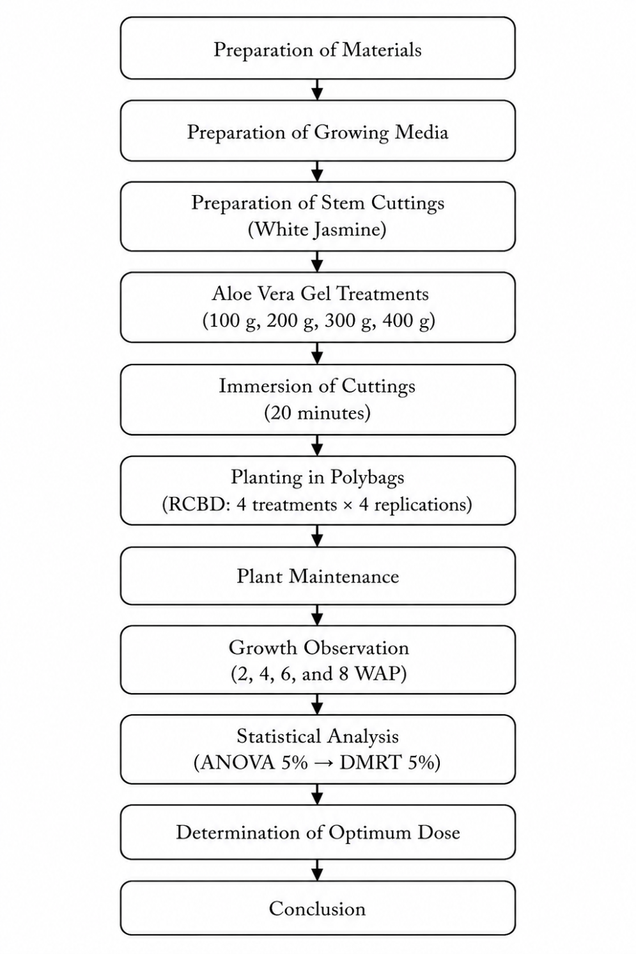
Figure 1. Research stages for evaluating the effectiveness of aloe vera gel as a natural plant growth regulator on the rooting and vegetative growth of white jasmine cuttings.

Plant materials and experimental design
The experiment was arranged in a Randomized Complete Block Design (RCBD) with a single factor consisting of four doses of aloe vera gel used as a natural plant growth regulator: 100 g (F1), 200 g (F2), 300 g (F3), and 400 g (F4). Each treatment was replicated four times, resulting in 16 experimental units. White jasmine (Jasminum sambac L.) stem cuttings approximately 15 cm in length with 2–3 nodes were collected from healthy and disease-free mother plants. Prior to planting, the basal ends of the cuttings were immersed in aloe vera gel according to the respective treatment for 20 min.
Growing media and planting
The growing medium consisted of soil, sand, and compost mixed at a ratio of 1:1:1 (v/v/v). Treated cuttings were planted in polybags and maintained under shaded conditions during the rooting phase. Routine irrigation and weed management were carried out throughout the experiment.
Data collection and statistical analysis
Growth observations were conducted up to 8 weeks after planting (WAP). Parameters measured included plant height (cm), number of leaves, number of roots, and root length (cm). Data were analyzed using analysis of variance (ANOVA) at the 5% significance level. When significant differences among treatments were observed, means were separated using Duncan's Multiple Range Test (DMRT) at p ≤ 0.05. Statistical analyses were performed using SPSS software.
RESULTS AND DISCUSSION
The application of aloe vera gel significantly affected the vegetative growth of jasmine cuttings. This effect was demonstrated by the increase in plant height, number of leaves, number of roots, and root length during the observation period. The analysis of variance results indicated that the treatments produced different growth responses for each observed parameter.

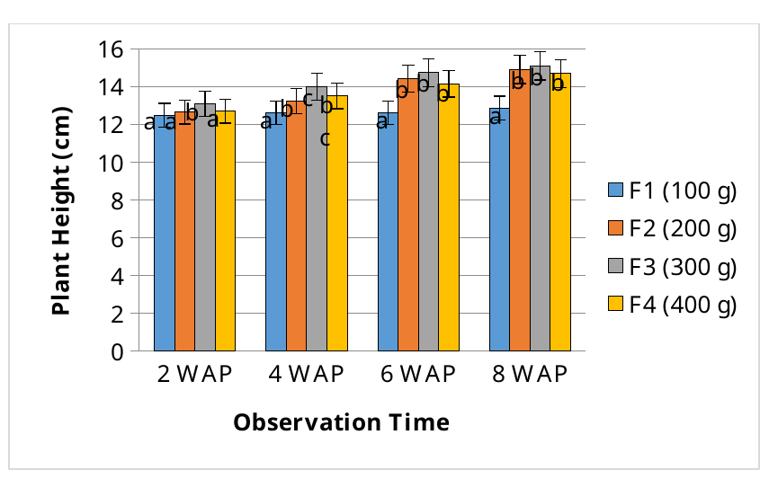
Figure 2. Plant height of jasmine cuttings as affected by aloe vera gel treatments. Bars with the same letter are not significantly different according to Duncan's Multiple Range Test (DMRT) at the 5% significance level (p <= 0.05).

The results showed a progressive increase in plant height throughout the observation period across all treatments. The tallest plants were obtained from cuttings treated with 300 g aloe vera gel, reaching 15.10 cm at 8 weeks after planting (WAP), whereas the lowest height was recorded in the 100 g treatment (Figure 2). The superior growth observed at the 300 g dose may be associated with the bioactive compounds present in aloe vera gel.

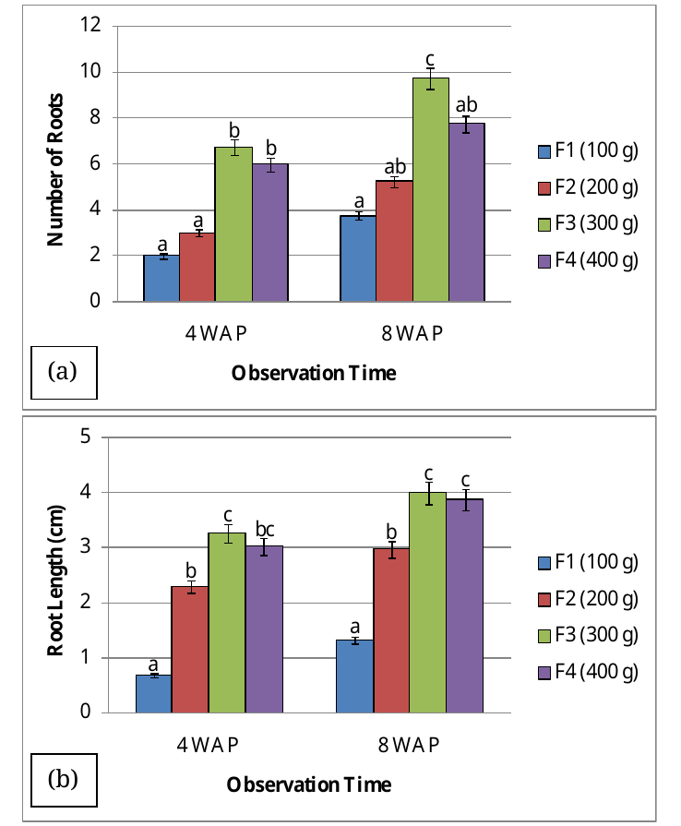
Figure 3. Root growth of jasmine cuttings as affected by aloe vera gel treatments: (a) number of roots and (b) root length. Bars followed by the same letter are not significantly different according to Duncan's Multiple Range Test (DMRT) at the 5% significance level (p <= 0.05).

Recent evidence has confirmed the presence of endogenous phytohormones, including gibberellins and cytokinins, which play important roles in cell elongation, cell division, and shoot development [10]. Aloe vera gel also contains amino acids, vitamins, sugars, and minerals that support metabolic and physiological activities related to plant growth [5,7]. Furthermore, improved root development may have enhanced water and nutrient uptake, thereby promoting shoot elongation during the establishment phase. Similar responses have been reported in white jasmine treated with natural growth-promoting substances [2], while aloe vera gel has been shown to improve growth performance in rose cuttings [8], Moringa oleifera seedlings [11], and in vitro-grown Populus plants [12]. Likewise, El-Banna et al. [9] demonstrated that plant-derived extracts enhanced the morpho-physiological performance of stem cuttings, supporting their role as natural biostimulants in vegetative propagation. These findings indicate that aloe vera gel can serve as an effective natural biostimulant for enhancing vegetative growth when applied at an appropriate dose.
Root development responded positively to the application of aloe vera gel (Figure 3). At 8 weeks after planting (WAP), cuttings treated with 300 g aloe vera gel produced the highest number of roots (9.75 roots plant⁻¹) and the greatest root length (4.00 cm), indicating superior rooting performance compared with the other treatments. The enhancement of root formation may be attributed to the presence of endogenous auxins and other bioactive compounds in aloe vera gel that stimulate root initiation and the development of adventitious roots [5][10]. In addition, aloe vera contains vitamins, amino acids, and minerals that support cell differentiation and root growth [7]. Similar observations were reported by Nasution et al. [8], who found that aloe vera gel promoted root growth in rose cuttings, demonstrating its potential as a natural plant growth regulator. Likewise, Mirihagalla and Fernando [13] reported improved rooting performance in stem cuttings treated with aloe vera gel. The effectiveness of aloe vera gel as a natural rooting agent has also been demonstrated in Ficus benjamina, where its application enhanced root formation under different propagation substrates [14]. Furthermore, Srivastava [15] highlighted aloe vera as one of the most promising organic rooting substances for horticultural crop propagation due to its rich composition of growth-promoting compounds. A well-developed root system enhances water and nutrient uptake, thereby improving plant establishment and supporting subsequent vegetative growth. The superior rooting response observed at the 300 g treatment suggests that this dose provided a favorable balance of growth-promoting substances for root development, whereas increasing the dose to 400 g did not result in further improvement. These findings are consistent with recent reports describing the effectiveness of aloe vera-based biostimulants in improving propagation success and growth performance in horticultural crops [16,17].
A similar trend was observed for leaf production (Figure 4). The application of 300 g aloe vera gel resulted in the highest number of leaves, averaging 9.50 leaves plant⁻¹ at 8 weeks after planting (WAP). Increased leaf production reflects enhanced meristematic activity and shoot development, which may be associated with the presence of endogenous phytohormones, particularly cytokinins, in aloe vera gel [10]. Cytokinins play a central role in stimulating cell division, shoot organogenesis, and leaf initiation, thereby promoting the formation of new vegetative organs [18,19]. In addition to regulating cell division and organ formation, aloe vera contains essential nutrients and bioactive compounds that support physiological processes involved in vegetative growth [5,7]. Improved root development observed under the 300 g treatment likely enhanced water and nutrient acquisition, thereby providing greater resources for leaf initiation and expansion. Previous studies have demonstrated that root system architecture strongly influences the efficiency of water and nutrient uptake, which subsequently supports aboveground growth and leaf development [20-24]. Similar responses have been reported in white jasmine treated with natural plant growth regulators [2]. The positive influence of aloe vera and other plant-derived extracts on vegetative growth has also been documented in Moringa oleifera seedlings [11], in vitro-grown Populus plants [12], and ornamental stem cuttings [9]. Furthermore, the synergistic interaction between auxins and cytokinins has been recognized as a key factor regulating shoot proliferation and vegetative development [25]. Although the 400 g treatment also promoted leaf development, its performance did not exceed that of the 300 g treatment. This finding suggests that plant responses to growth-promoting substances follow an optimum-dose pattern, in which excessive concentrations may disrupt hormonal balance and reduce physiological efficiency.

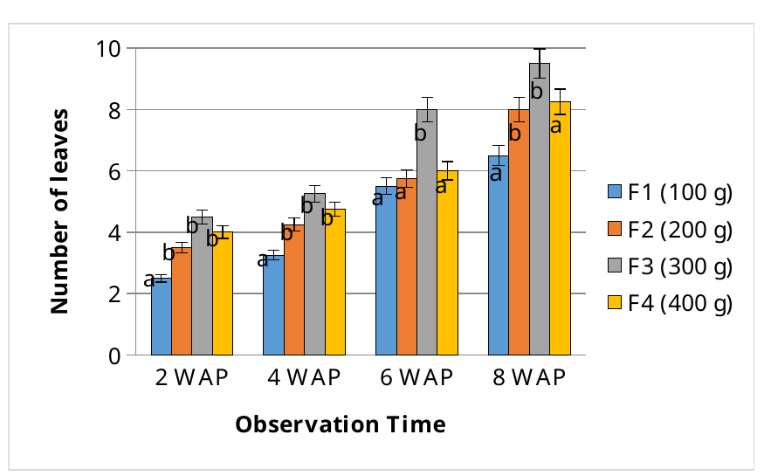
Figure 4. Number of leaves of jasmine cuttings as affected by aloe vera gel treatments. Bars followed by the same letter are not significantly different according to Duncan's Multiple Range Test (DMRT) at the 5% significance level (p <= 0.05).

Overall, the results demonstrate that aloe vera gel can serve as an effective natural plant growth regulator for white jasmine propagation. Among the tested treatments, the application of 300 g aloe vera gel provided the most favorable balance between root and shoot development, creating optimal hormonal conditions for leaf formation and vegetative growth. Consequently, this treatment resulted in the highest overall vegetative performance compared with the other treatments.
CONCLUSION
The application of aloe vera gel significantly influenced the rooting and vegetative growth of white jasmine (Jasminum sambac L.) cuttings. Among the tested treatments, the application of 300 g aloe vera gel produced the best overall growth performance. At 8 weeks after planting, this treatment resulted in the highest plant height (15.10 cm), number of leaves (9.50 leaves plant⁻¹), number of roots (9.75 roots plant⁻¹), and root length (4.00 cm). These findings indicate that 300 g aloe vera gel is the optimum dose for promoting rooting and vegetative growth and demonstrate its potential as an effective natural plant growth regulator for improving the success of white jasmine propagation through stem cuttings.
ACKNOWLEDGMENT
The authors would like to express their sincere appreciation to the Plant Science Laboratory, Department of Agrotechnology, Faculty of Agriculture, Universitas Borneo Tarakan, for providing research facilities and support. The authors are also grateful to Wichart Flower for providing the plant cuttings used as experimental materials and to all parties who contributed to the completion of this study.
REFERENCES
[1] Yassen MS, Ayoub IM, El-Ahmady SH, Singab ANB. Comparative analysis of flower volatiles from four Jasminum species growing in Egypt using multivariate analysis. Sci Rep. 2026;16(1):8947. doi:10.1038/s41598-026-39688-w.
[2] Agustinur, Harahap EJ, Lizmah SF, Muslimah Y, Irfan B. The effect of various natural growth regulatory substances and the origin of stem cuttings on the vegetative growth of white jasmine (Jasminum sambac L.). IOP Conf Ser Earth Environ Sci. 2023;1241:012023. doi:10.1088/1755-1315/1241/1/012023.
[3] Sodi DK, Markam PS, Sahu TL, Shankar D, Nishad D. Effect of different growing media and types of stem cuttings on rooting of jasmine (Jasminum sambac L.). Int J Res Agron. 2024;7(7):890–896. doi:10.33545/2618060X.2024.v7.i7k.1151.
[4] Muslimah Y, Lizmah SF, Fayanti N. Growth response of melati plant (Jasminum sambac L.) against types of media plants and types of growing agents. Budapest Int Res Exact Sci (BirEx) J. 2020;2(2):188–200. doi:10.33258/birex.v2i2.893.
[5] Rajan RP, Singh G. A review on the use of organic rooting substances for propagation of horticulture crops. Plant Arch. 2021;21(Suppl 1):685–692. doi:10.51470/PLANTARCHIVES.2021.v21.S1.103.
[6] Prisa D, Matsoukis A, Jamal A, Spagnuolo D. Environmental impacts of plant growth regulators in modern agriculture: advances, risks, and sustainable perspectives. Agrochemicals. 2026;5(1):14. doi:10.3390/agrochemicals5010014.
[7] Wijesundara I, Basooriya SS, Kumarasinghe S, Dissanayake RDVR. Potential of organic rooting substances in horticultural crop propagation: a comprehensive review with a focus on aloe vera gel, coconut water, and bee honey. In: Proceedings of the 8th International Research Conference of Uva Wellassa University; 2024 Jul; Uva Wellassa University, Sri Lanka. 2024.
[8] Nasution WR, Batubara PRH, Sigalingging DM, Hasibuan LH. Utilization of Aloe vera as a natural ZPT alternative for the growth of rose plant roots. Bioedunis J. 2023;2(1):34–38. doi:10.24952/bioedunis.v2i1.8214.
[9] El-Banna H, Haroun SA, Albishi TS, Rashed AA, Albadrani M, Abdelaal K, Alkhateeb OA, Abdou AH. The natural alternatives: the impact of plant extracts on snowbush (Breynia disticha Forst.) cuttings' morpho-physiological and biochemical characteristics. Horticulturae. 2023;9(10):1122. doi:10.3390/horticulturae9101122.
[10] Hakeem MK, Maraqa M, Elangovan SK, Saeed EE, Mishra AK, Hazzouri KM, Shah I, Amiri KMA. Innovative determination of phytohormones in Aloe vera. Front Chem. 2025;12:1490639. doi:10.3389/fchem.2024.1490639.
[11] Chachar M, Memon SA, Miano TF, Chachar S, Majeedano MI, Chachar ZA, Chachar SA, Ullah R, Jiskani SS, Mehmood T. Effect of different concentrations of Aloe vera gel on seed germination and growth of moringa (Moringa oleifera). J Agric Vet Sci. 2025;4(3):285–297. doi:10.55627/agrivet.004.03.1502.
[12] El Sherif F. Aloe vera leaf extract as a potential growth enhancer for Populus trees grown under in vitro conditions. Am J Plant Biol. 2017;2(3):101–105. doi:10.11648/j.ajpb.20170203.13.
[13] Mirihagalla MKPN, Fernando KMC. Effect of Aloe vera gel for inducing rooting of stem cuttings and air layering of plants. J Dry Zone Agric. 2020;6(1):13–26. Available from: https://ir.lib.ruh.ac.lk/xmlui/handle/iruor/8814

[14] Alvarado-Aguayo A, Munzón-Quintana M. Evaluación de la efectividad de gel de sábila y agua de coco como enraizantes naturales en diferentes sustratos para propagación asexual de árboles de Ficus benjamina. Agron Costarricense. 2020;44(1):65–78. doi:10.15517/RAC.V44I1.40002.
[15] Srivastava MP. Natural root promoting substances for rooting of horticulture crops. Int J Res Mol Immunol. 2023;1(1). doi:10.53555/mi.v1i1.2305.
[16] Maghfirah, Liyanda M, Agustina S, Maharani A. Efektivitas gel lidah buaya sebagai ZPT alami terhadap keberhasilan grafting bibit mangga madu (Mangifera indica). ROCE J Pertan Terapan. 2025;2(2). doi:10.71275/roce.v2i2.133.
[17] Kant K, Gupta S, Kaur N, Jindal P, Ali A. Effect of Aloe vera extract on the cultivation practices of Rosa damascena Mill. Environ Ecol. 2025;43(1A):239–244. doi:10.60151/envec/YTZV4304.
[18] Raspor M, Motyka V, Kaleri AR, Ninković S, Tubić L, Cingel A, Ćosić T. Integrating the roles for cytokinin and auxin in de novo shoot organogenesis: from hormone uptake to signaling outputs. Int J Mol Sci. 2021;22(16):8554. doi:10.3390/ijms22168554.
[19] Šmeringai J, Schrumpfová PP, Pernisová M. Cytokinins—regulators of de novo shoot organogenesis. Front Plant Sci. 2023;14:1239133. doi:10.3389/fpls.2023.1239133.
[20] Yan M, Zhang L, Ren Y, Zhang T, Zhang S, Li H, Chen Y, Zhang S. The higher water absorption capacity of small root system improved the yield and water use efficiency of maize. Plants (Basel). 2022;11(17):2300. doi:10.3390/plants11172300.
[21] Holz M, Zarebanadkouki M, Benard P, Hoffmann M, Dubbert M. Root and rhizosphere traits for enhanced water and nutrients uptake efficiency in dynamic environments. Front Plant Sci. 2024;15:1383373. doi:10.3389/fpls.2024.1383373.
[22] Lynch JP. Root architecture and plant productivity. Plant Physiol. 1995;109(1):7-13. doi:10.1104/pp.109.1.7.
[23] Koevoets IT, Venema JH, Elzenga JTM, Testerink C. Roots withstanding their environment: exploiting root system architecture responses to abiotic stress to improve crop tolerance. Front Plant Sci. 2016;7:1335. doi:10.3389/fpls.2016.01335.
[24] Lynch JP. Rightsizing root phenotypes for drought resistance. J Exp Bot. 2018;69(13):3279-3292. doi:10.1093/jxb/ery048.
[25] Yasmin S, Hasan J, Hossain S, Saha S, Khatun F. Auxin and cytokinin synergism in micropropagation for mass production of Aloe vera. Biotechnologia. 2022;103(3):301-310. doi:10.5114/bta.2022.118672.

